**Zadanie 1:**

1. **Perceptor z dwoma wejściami reprezentującymi** 

|  |  |  |
| --- | --- | --- |
| **X1** | **X2** | **X1 ^ ~X2** |
| **0** | **0** | **0** |
| **0** | **1** | **0** |
| **1** | **0** | **1** |
| **1** | **1** | **0** |

**X0<=0**

**w0 + w2 <= 0**

**w0 + w1 > 0**

**w0 + w1 + w2 <= 0**

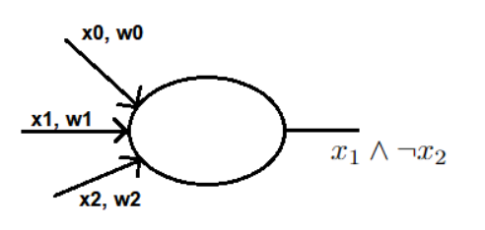

**w0 = -2**

**w1 = 3**

**w2 = -1,5**

1. **Dwuwarstwowa sieć implementująca **

|  |  |  |  |  |
| --- | --- | --- | --- | --- |
| **X1** | **X2** | **X1 V X2** | **~(X1 ^ X2)** | **(X1 V X2) ^(~(X1 V X2))** |
| **0** | **0** | **0** | **1** | **0** |
| **0** | **1** | **1** | **1** | **1** |
| **1** | **0** | **1** | **1** | **1** |
| **1** | **1** | **1** | **0** | **0** |

**w1,0 <= 0 w2,0 > 0**

**w1,0 + w1,2 > 0 w2,0 + w2,2 > 0 w3,0 + w3,2 <= 0**

**w1,0 + w1,1 > 0 w2,0 + w2,1 > 0 w3,0 + w3,1 + w3,2 > 0**

**w1,0 + w1,1 + w1m2 > 0 w2,0 + w2,1 + w2,2 <= 0 w3,0 + w3,1 <= 0**

**w1,0 = -1**

**w1,1 = 2 w2,0 = 3 w3,0 = -3**

**w1,2 = 2 w2,1 = -2 w3,1 = 2**

**w2,2 = -2 w3,2 = 2**

